***Matrix calculation dot product of two 3x3 matrices***

1. **Top deisgn.**

Consist of:

* Dot product unit.
* The Finite State Machine (FSM) unit.

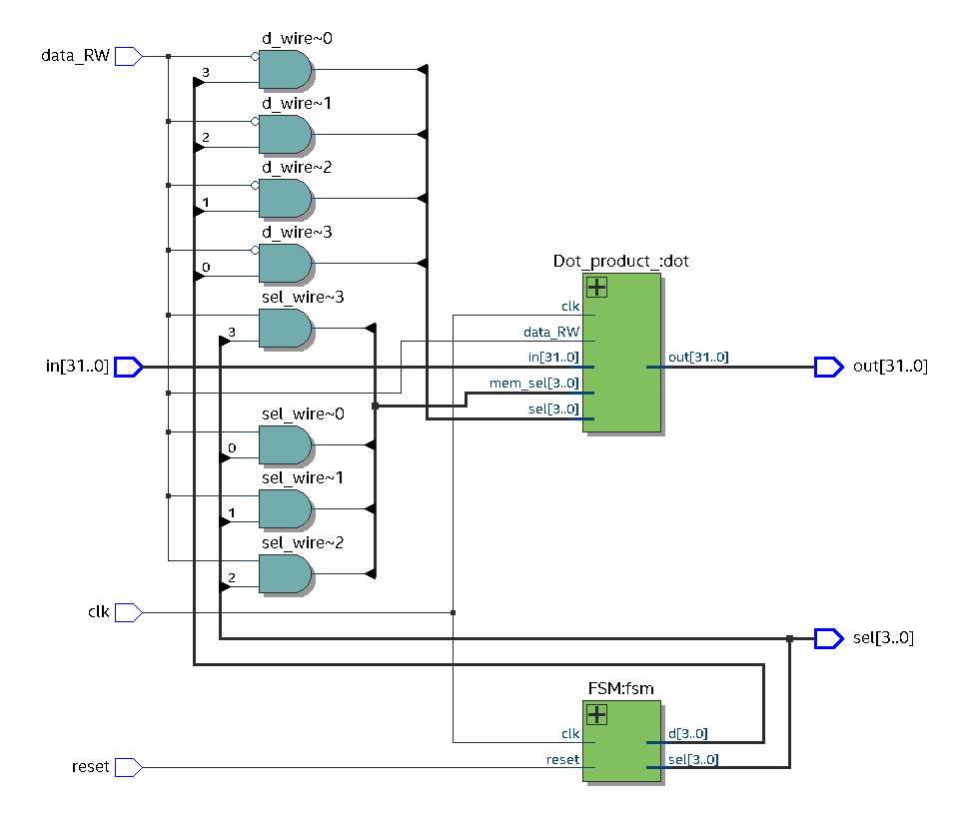

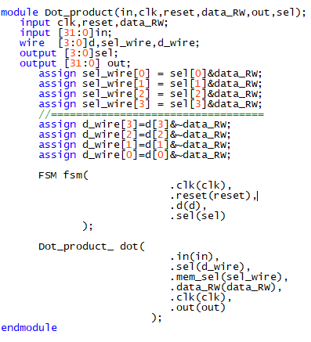

1. **Internal parts.**

* **Dot product unit**:

Consist of 3 main components: register memories, row and column of matrix selector

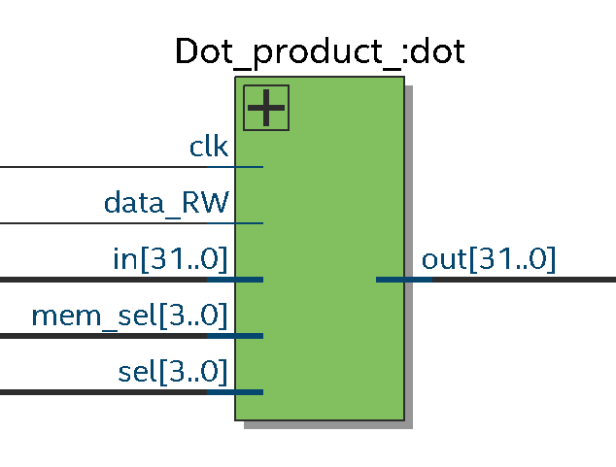

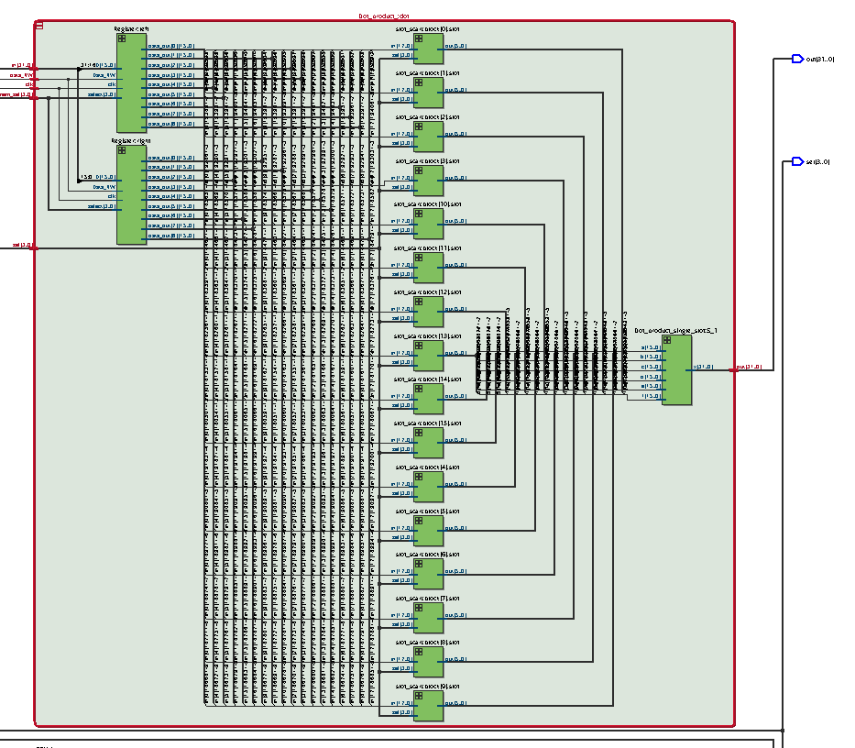

Consist of **2 memory register** 16x16 to get 18 inputs from two matrix 3x3, 18 **input row and column selector** (3x3 to 3x1 mux).a dot product calculator comprised of 16bits **multiplier** and 32bits **adder** all of them are unsigned.

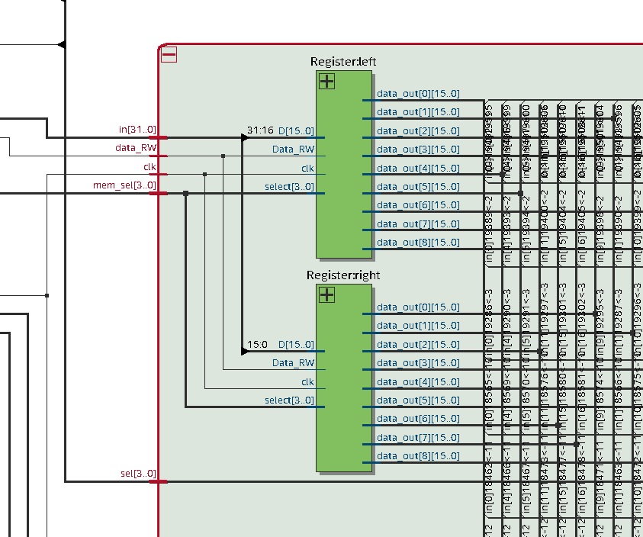

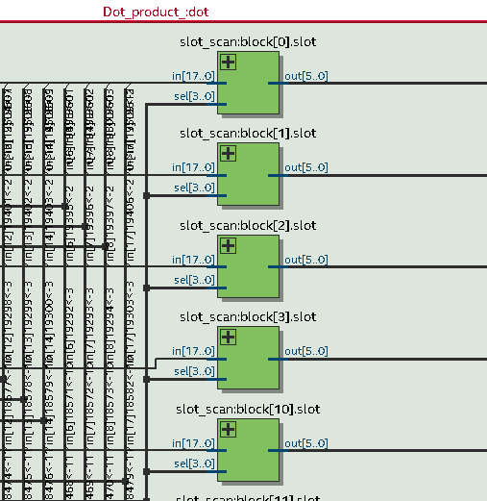

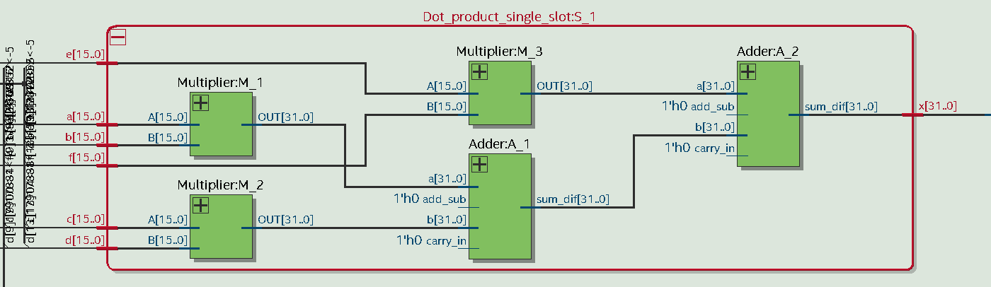

* **FSM:**

It simply a **counter** from 0 to 9 in order to run a sequence to switch address of the two **registers memory** in the dot product unit that load input into the matrix calculation module, and also another sequence made by the **FSM unit** to calculate single slot of the output matrix and put it in the **register memory at the end of output.**

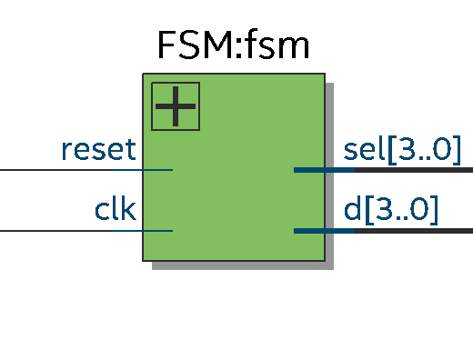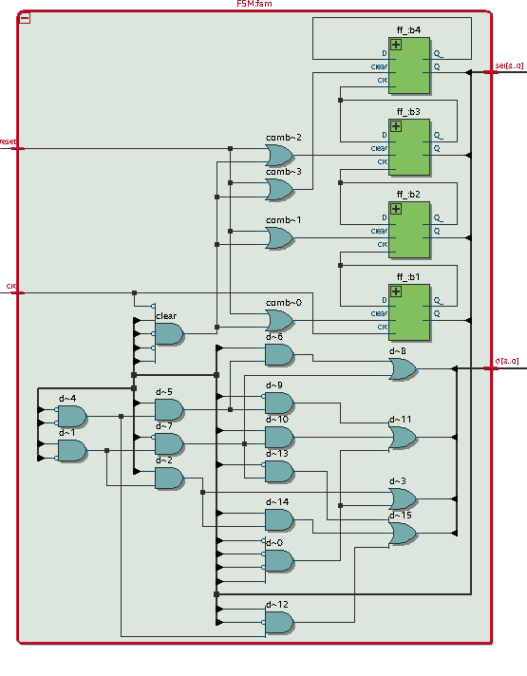

1. ***Simulation***

Below is the testbench that have clock, reset signal, selection outputs, read and Write enabler, input, and register memory to save the computed matrix:

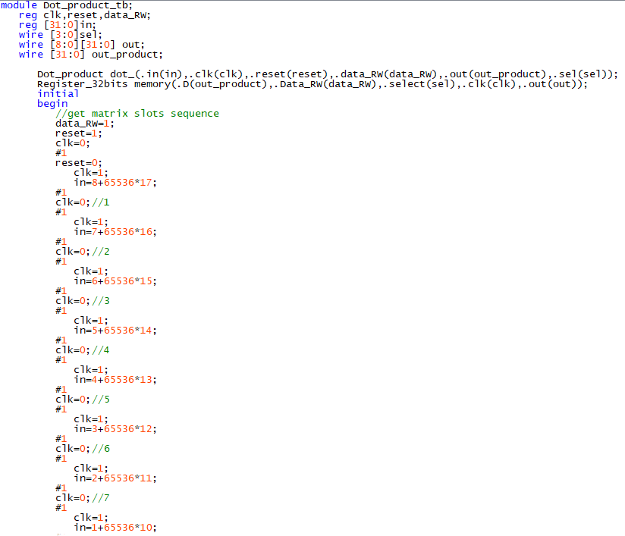

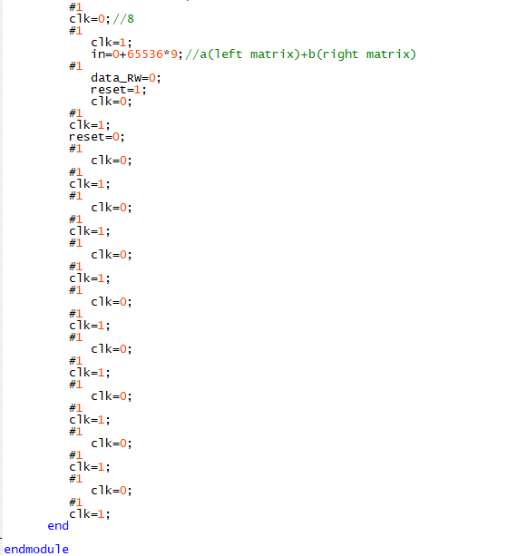

1. ***Result:***

***The result of the dot product of two 3x3 matrices:***

we use the two matrix below to use as an example for demonstrating the dot product calculation.

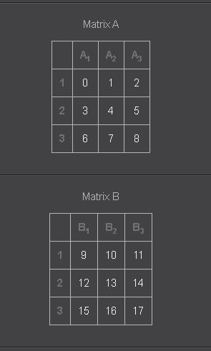 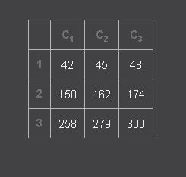

***Modelsim simulation:***

